Configuration Management System Usage Procedure

配置管理系统使用程序

|  |  |  |
| --- | --- | --- |
| Author | Reviewer | Approver |
|  |  |  |

**Version Control**

|  |  |  |
| --- | --- | --- |
| **Version** | **Date** | **Description** |
| 0.1 | 09/09/2019 | First document release |
| 0.2 | 27/09/2019 | Updated to new format |
| 0.3 | 13/11/2019 | Minor changes applied to the document |
| 0.4 | 10/11/2020 | Minor changes |

**Contents**

1 Objective 4

1.1 Scope 4

1.2 Responsibility 4

2 Git Usage Procedure 5

2.1 CM Item List 5

2.2 Documents naming rules 5

2.3 Inputting Item 6

2.4 CM Item Management 6

3 Enterprise Resource Planning (ERP) 7

3.1 Main Function 7

3.2 Related Roles 8

3.3 Access Rights Granting, Changing and Revoking 8

1. Objective

The documentation and data maintained by the configuration management system could be controlled correctly.

通过配置管理系统的使用，确保所有位于配置管理系统中管理的文件以及数据都能够正确的控制。

* 1. Scope

This procedure is formulated to cover the company policy, procedure, technical documents, forms and tables, etc.

适用于公司政策、程序表单，技术文档等的维护。

* 1. Responsibility

Security manager is the administrator of the Git.

安全经理为Git的管理员。

IT assistant and IT engineer know half of the login password for the Git, Git could be used by them only the 2 persons inputing the password together according to the 4 eyes principle.

IT助理以及IT工程师各自掌握掌握Git登录密码的一部分，确保每次他们对于Git的使用都有两个人在场，达到四眼原则。

The IT engineer and IT assistant are responsible for formulation, security manager is in charge of the reviewing and the approval of this document.

IT工程师和IT助理负责本文档的制定，安全经理负责审核和审批。

1. Git Usage Procedure
   1. CM Item List

The following items will be controlled regarding to the version by the Git:

以下内容将作为配置管理项放入Git中进行版本管理：

* Technical Documents related with packaging

封装相关的技术文档

* The management policy, procedure, forms and tables

公司管理体系政策、程序以及表单

* CC documents

CC文档

* Operation log or production process information generated by ERP

ERP生成的操作日志或者生产信息

All the CM items should be listed on the CM Item List.

所有的配置管理项，统计并记录在《配置管理项列表》上。

The CM Item List will be reviewed comparing with the actual management in Git by security manager every quarter and shall sign on the list.

《配置管理项列表》每季度由安全经理对比Git的实际管理内容进行检查，并签名确认。

* 1. Documents naming rules

For the naming rule of CC documents, it is formed by

对于CC文档的命名，它由以下组成

(company name abbreviation)-(confidential level abbreviation)-(type of document)-(version)

(公司名称缩写)-(机密级别缩写)-(文档类型)-(版本)

Take an example: CTWY-C-CMC-0.3

例如：CTWY-C-CMC-0.3

For the naming rule of other documents, there is no specific rule defined since Git will assign each item with a unique id, as long as the name used can explicitly describe the content.

对于其它文档的命名，因为Git会给每一项赋予一个独一无二的ID，所以没有使用特定的规则，只要使用的名称能够清晰地描述文档内容。

* 1. Inputting Item

The applicant who wants to input the items into Git for the version control must fill in the CM Item Inputting Application Form. The inputting operation must be conducted by IT assistant under the supervision of IT engineer after the approval of IT engineer. At the same time, it shall be recorded in the CM Item List.

所有需要添加入Git进行管理的文件，在录入前，须由申请人填写《配置管理项录入申请表》，得到IT工程师批准之后，在IT工程师的监督下由IT助理负责录入，并记录在《配置管理项列表》上。

* 1. CM Item Management

All the CM items should be identified with the unique ID in the Git.

所有的CM项都必须在Git中标识有唯一的ID。

The name, version number, ID, operator name, modification personnel name, modification contents, time and authorized personnel name of CM items controlled by Git should be recorded automatically.

在Git中的所有配置项的名称、版本号、ID、操作人员、变动人员、变动内容、时间以及授权人员等相关版本控制信息都应该自动记录下来。

Every single account has defined rights. Only authorized personnel can modify policies, procedures, etc. in the system.

每个单独的账号都定义了权限，只有经过授权的人员才能修改系统中的策略、流程等。

The security manager has the read only access rights for Git and also could grant the privilege to others.

安全经理拥有Git的只读权限而且能够分发权限给他人。

An operator account having read and write access rights is shared with IT engineer and IT assistant by providing half of the password to each of them.

一个拥有读写权限的操作员账号共享给IT工程师和IT助理，通过提供给每人一半密码。

All the employees having the access rights to Git are recorded in the Git Access Right Form.

所有拥有Git权限的员工都被记录在《Git权限列表》中。

Security manager shall review and confirm the Git Access Right List every quarter.

安全经理须每季度审查并确认《Git权限列表》。

1. Enterprise Resource Planning (ERP)

The Enterprise Resource Planning (ERP) system used here is called Kingdee Cloud system, which is aimed for the quality management of the production, to avoid the inconvenience of inputting too much production data.

生产管理系统（以下简称ERP），用于针对公司录入的数据太过繁多，便于进行生产质量管理。

The major function of the ERP is inputting, inquiring, deleting, modifying, summarizing and printing out, etc. the production data.

ERP的主要功能是与生产质量相关数据的录入、查询、删除、修改、汇总、打印输出等。

Every single item in the ERP System will contain a unique LotID that will track the configuration item in the system.

ERP系统中的每个项目都将包含一个唯一的LotID，该LotID将会跟踪系统中的配置项目。

* 1. Main Function

The data related with the production during the whole product lifecycle will be recorded into the ERP for tracking.

所有与生产相关的数据，在模块封装的产品生命周期中都将录入系统中进行追踪并管理。

The whole production process is managed and tracked by using ERP and Packaging Production Procedures Control Form.

整个生产过程均由ERP和封装生产流程控制表来完成管理和追踪。

Following identification numbers are tracked:

以下的标识数字被追踪：

* Production Lot Number 生产批次号
* Product Type (align Chip Type with Reel Type) 产品类型 (将芯片类型和条带类型对应)
* Reel Type 条带型号
* Chip Type 芯片型号
* Production Quantity 生产数量
* Production Steps 生产步骤
* Wafer Number 硅圆识别号
* Reel Number 条带识别号
* Device Number 设备号
* Operator 操作员
* Production Date 生产日期

Other information related with production is also input into ERP and Packaging Production Procedures Control Form:

其它与生产相关的信息也被记录到ERP和封装生产流程控制表中：

* Gold wire specification金线规格
* Die bonding glue type 贴片胶水类型
* Test requirements 测试要求
* Successful outcome quantity 合格品数量

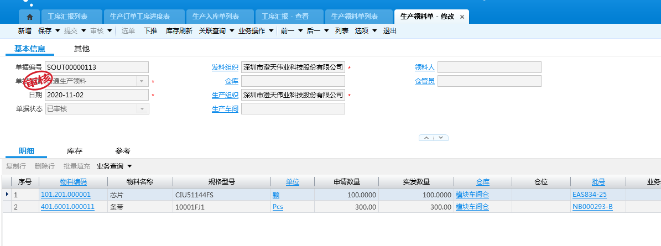

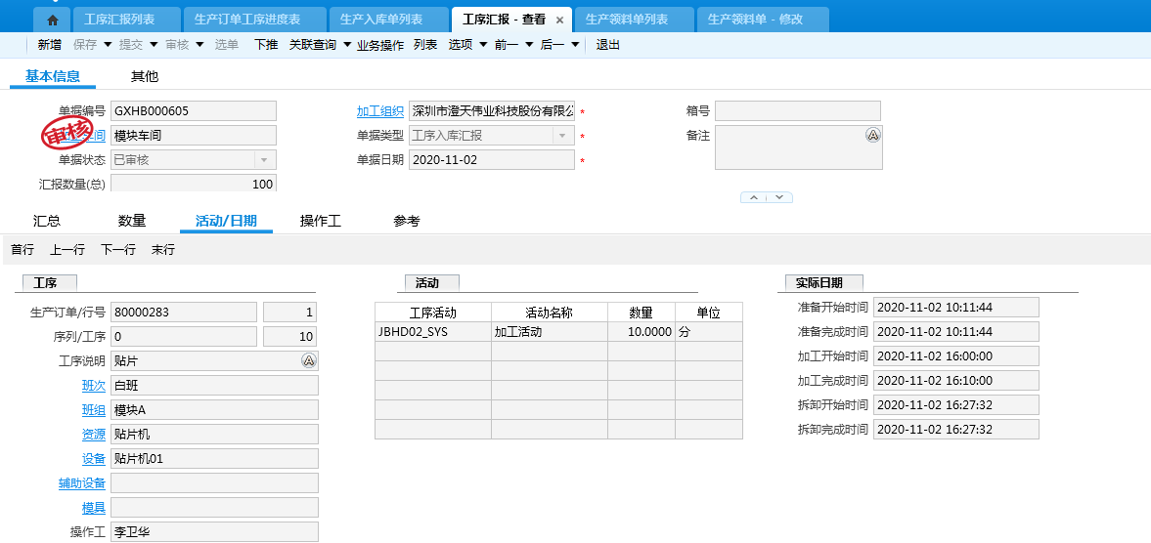

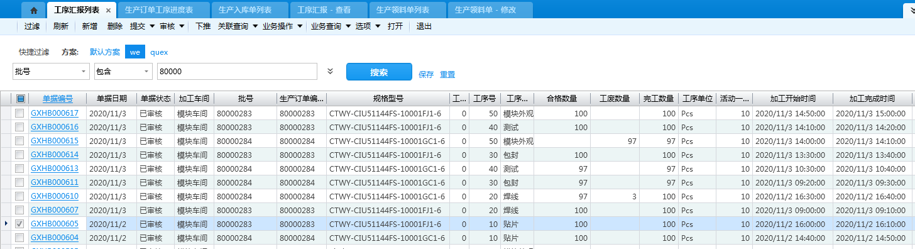

ERP used here is a proprietary software bought from third-party and the server is located outside of the factory. However, the data communication between the remote server and the local client is achieved by https encrypted protocol. The contract includes the confidentiality agreement clause enforcing the third-party developer and remote server operator to preserve the confidentiality and integrity of the data input into the ERP.

这里使用的ERP是从第三方购买的有版权的软件而且服务器位于站点之外。然而远程服务器和本地客户端的通信使用了https加密协议。购买合同中也包含了保密协议条款从而强制第三方开发者和远程服务器运营人员保护录入ERP信息的机密性和完整性。

For more detail, please refer to the ERP Operation Guide Documentation.

请参考《ERP使用说明》。

* 1. Related Roles

Production Group: in charge of generating and editing the production data which has been recorded in ERP.

只有生产部工程师有权限对各工序已经录入的信息进行相关操作。

IT engineer: in charge of administrator account of the ERP and manage ERP user accounts.

IT工程师负责ERP管理员账号地使用并且管理ERP用户账号。

Packaging workshop manager and production operators will perform the daily production data management based on their roles and responsibilities.

车间主管和生产操作员会根据各自的角色和职责来执行日常生产数据的管理。

* 1. Access Rights Granting, Changing and Revoking
     1. Granting Access Rights

The employee applying for granting accounts of the ERP shall fill in the ERP Account Access Right Changing Application Form.

ERP系统帐号在开通前，申请员工须填写《ERP账户权限变更申请表》。

The account access right for the ERP shall be granted based on the “need to know” principle.

ERP账户权限的授权必须基于“需要知道”的原则。

IT engineer shall register the account for the applicant after being confirmed by the applicant’s belonging department manager.

在部门经理同意之后，交由IT 工程师进行账户注册。

* + 1. Access Rights Changing

The employee who wants to change the access rights of ERP should fill in the ERP Account Access Right Changing Application Form.

由于职责原因需要变动权限，须填写《ERP账户权限变更申请表》。

The change of account access right for the ERP shall be granted based on the “need to know” principle.

ERP账户权限变更的授权必须基于“需要知道”的原则。

IT engineer shall change access right of the account for the applicant after being confirmed by the applicant’s belonging department manager.

在部门经理同意之后，交由IT 工程师进行账户权限更改。

* + 1. Account Revoking

The accounts for ERP shall be revoked for the terminated employee.

员工离职时，要对该员工所管理的ERP账户进行注销。

The account revoking operation information must be recorded on the Termination Checklist.

并在《员工离职交接单》上登记相关操作信息。

* + 1. Account Management

The account of the ERP shall be recorded on the ERP Access Right Form.

ERP中车间所有相关人员的账户信息都将被记录在《ERP权限列表》上。

Security manager shall review and confirm the ERP Access Right Form every quarter to ensure there is no redundancy and shared accounts.

安全经理须每季度审查并确认《ERP权限列表》以确认不存在冗余或共享的账号。

1. Production procedures
   1. Production preparation

Production plan team will input the identification information mentioned in section 3.1 into ERP and at the same time fill the Packaging Production Procedures Control Form with the same identification information required by ERP after being approved by production director. Then production plan team will print the Packaging Production Procedures Control Form and Production Steps Tags. Then these two materials will be transferred to production manager for the use of later production.

在生产总监批准后，生产计划组会把3.1章节提到的识别信息输入到ERP，与此同时将同样的ERP需要的识别信息填入到《封装生产流程控制表》。之后生产计划组将会打印出《封装生产流程控制表》和《生产步骤标签》。然后这两份材料将会转交给生产经理以备后续生产。

* Packaging Production Procedures Control Form

《封装生产流程控制表》

This form concludes all the required information related with this production process. It is used to guide production operator to finish this production and record results of each production step.

这张表格总结了所有生产过程中需要的相关信息。它用来引导操作员完成本次生产并且留下每个生产步骤的结果。

* Production Steps Tag

《生产步骤标签》

This tag will be attached to reels used after each production step and it can indicate what the production Lot number is, what the production type it is, production amount and most important which production step it is on.

每个生产步骤完成之后，这个标签将会被贴到条带上。它可以显示出生产批号、生产类型、生产数量和最重要的生产步骤。

See the photo below, the left side paper has 4 Production Step Tags and each of them will be attached to reels after finishing each production step. Paper in the right is an example of Packaging Production Procedures Control Form listed all the information required to proceed with production.

查看下面的照片，左边的纸张上有4个《生产步骤标签》，它们中的每一个在完成每个生产步骤后都将被贴到条带上。右边的纸张是一份《封装生产流程控制表》样本，其中列出了所有生产需要的信息。

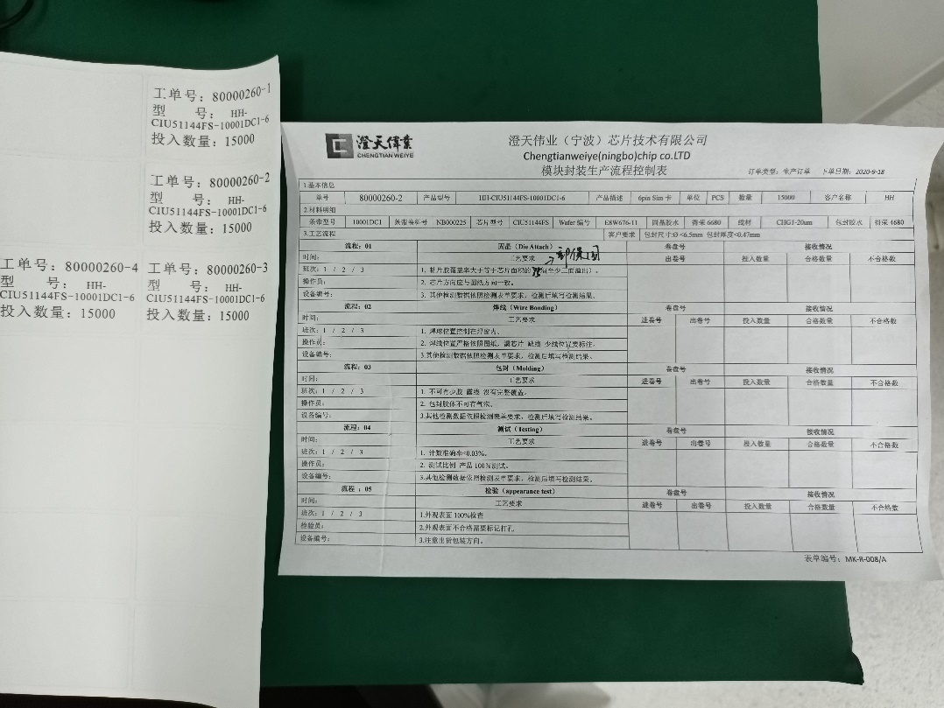

* 1. Production

During production, firstly operator needs to invoke the identification information already input into ERP by production plan team. Then by referring to the Packaging Production Procedures Control Form already printed, operator will follow the guidance of Packaging Production Procedures Control Form and attach corresponding Production Step Tag to the right reel whenever one production step is over. After finishing each production step, production results will be written in the Packaging Production Procedures Control Form and be input into ERP at the same time. Therefore, each production Lot will leave printed data and electronic data that could trace all the information needed for production during every step of the production.

在生产过程中，首先操作员需要调用已经被生产计划组输入ERP的识别信息。之后通过使用打印好的《封装生产流程控制表》，操作员将会跟着《封装生产流程控制表》的引导并在每个生产步骤完成后粘贴相应的《生产步骤标签》到正确的条带上。完成一个生产步骤后，生产结果将会手写到《封装生产流程控制表》上并且同时输入到ERP中。因此每一个生产批次都将留下纸质数据和电子数据，这些数据能够追踪到每个生产步骤中的所有需要的信息。

* 1. Post-production

Since the production process record information will exist both in physical format and electronic format, the data in two formats shall be kept secure all the time.

因为生产流程记录信息同时以物理格式和电子格式存在，数据的两种格式都应一直被安全地保护。

Packaging Production Procedures Control Form used after production will be kept by quality department for at least 3 years.

使用的《封装生产流程控制表》在生产完后将被质量部门至少保存3年。

Production data stored in ERP is in remote server, it can be regarded as a remote backup.

存储在ERP中的生产数据位于远程服务器，这可以被视为一种远程备份。

At the end of each workday, IT assistant and IT engineer will export electronic production data and then transfer it to local Git server for retention. This process is done following four-eye principle.

在每个工作日的最好时间，IT助理和IT工程师将会导出电子生产数据并且转移到本地Git服务器以作保留。这个过程在四眼原则下完成。

Production director will compare the physical production data and electronic production data periodically with the help of IT assistant and/or IT engineer in order to prevent the mismatching of the production data.

生产总监将会在IT助理或IT工程师的帮助下比对物理生产数据和电子生产数据，以防止生产数据的不匹配。